This project details the design and implementation of a comprehensive banking analytics system, leveraging SQL/RDBMS for data management and Power BI for visualization. A normalized relational database was established to efficiently handle banking operations while maintaining data integrity and consistency. Advanced SQL queries were utilized to extract actionable business insights from various data sources, including customer, account, transaction, loan, and branch information. The resulting analytical data was integrated into interactive Power BI dashboards through an optimized data model. The system encompasses several key analytical components: Customer 360 Analysis, Customer Segmentation, Loan Risk Assessment, Branch Performance Analysis, and Product Analytics. The overall system illustrates the application of data-driven business intelligence to inform strategic decisions and enhance operational effectiveness within the banking industry.
Udayan Maiti

Banking Analytics System
A Comprehensive SQL and Power BI Business Intelligence Solution

Table of Contents:
Contents
Table of Contents: 1
Abstract: 8
Chapter 1: Project Overview 9
Background 9
Business Problem 9
Business Objectives 9
Scope of the Project 10
1. Database Engineering & ETL 10
2. Analytical View Layer 10
3. Business Intelligence Dashboards 10
Technologies Used 11
Expected Business Outcomes 11
Conclusion: 12
Chapter 2: Database Design 13
Executive Summary 13
Rationalizing the Relational Database Choice 13
Database Architecture Overview 13
1. The Transactional Layer (Base Tables) 13
2. The Analytical View Layer (Reporting Layer) 13
3. The Visualization Layer (Star Schema) 14
Entity-Relationship (ER) Design and Table Purposes 14
Relationship Explanation and Data Flow 15
a. Customer-Account Relationship (One-to-Many) 15
b. Account-Transaction Relationship (One-to-Many) 15
c. Branch-Account Relationship (One-to-Many) 15
d. Customer-Loan Relationship (One-to-Many) 15
Normalization Process and Structural Integrity 16
Handling Join Multiplication 16
The Analytical View Architecture (Reporting Layer) 16
1. vw_customer_360: 16
2. vw_customer_activity: 16
3. vw_customer_primary_branch: 16
4. vw_customer_value_segment: 16
5. vw_high_value_customers: 16
6. vw_approved_loan_portfolio: 16
7. vw_loan_application_risk: 16
8. vw_loan_product_analysis: 16
9. vw_loan_product_risk_analysis: 16
10. vw_loan_risk_analysis: 17
11. vw_credit_risk_summary: 17
12. vw_branch_performance: 17
13. vw_branch_loan_reconciliation: 17
14. vw_transaction_activity: 17
15. vw_transaction_kpis: 17
16. vw_account_product_analysis: 17
17. vw_executive_kpis: 17
Conclusion 17
Chapter 3: SQL Development 18
Introduction 18
Data Exploration 18
Validating Relationships and Cardinality 18
Identifying Anomalies 19
Data Cleaning 19
Implementing Business Logic through SQL 19
Defining the "Primary Branch" 19
Risk Tiering Logic 20
Analytical SQL Techniques 21
CASE Expressions: The Engine of Segmentation 21
Window Functions: Ranking and Trends 22
Common Table Expressions (CTEs): Managing Complexity 23
Solving the "Join Multiplication" Problem 24
The Problem 24
The Solution: Pre-Aggregation 24
Separating Origination from Portfolio Exposure 27
The Customer 360 View (vw_customer_360) 27
Stored Procedures: 28
The Operational Search Engine: sp_Get_Customer_Profile 28
Real-time Engagement Monitoring: sp_Get_Customer_Transaction_Summary 28
Strategic Advantage of Procedures in Banking 29
SQL Optimization Decisions 29
Conclusion: An Analytical Framework 29
Chapter 4: Power BI Development 30
Executive Summary 30
The Data Model Architecture 30
The Analytical View Layer (SQL-to-BI Interface) 30
Star Schema Implementation 30
Disabling Automatic Relationships 31
Dashboard Design Philosophy and Visual Selection 32
Bank Performance Overview 32
Customer Analytics Dashboard 33
Loan Risk Dashboard 33
Branch Performance Dashboard 34
Product Analysis Dashboard 35
Transaction Activity Dashboard 35
DAX Measures and Technical Refinement 36
Formatting and Professional Polish 36
Conclusion 37
Chapter 5: Dashboard Documentation 38
Introduction 38
Development Methodology 38
Bank Performance Overview: 39
Business Objective: 39
Target Audience: 39
Visual Design Rationale: 39
Business Questions Answered: 39
Business Value: 39
Customer Analytics Dashboard: 40
Business Objective: 40
Target Audience: 40
Visual Design Rationale: 40
Business Questions Answered: 40
Business Value: 40
Loan Risk Dashboard: 41
Business Objective 41
Target Audience 41
Architectural Design Decision 41
Visual Design Rationale 41
Business Questions Answered 41
Business Value 41
Branch Performance Dashboard: 42
Business Objective 42
Target Audience 42
Data Governance Consideration 42
Business Questions Answered 42
Business Value 42
Product Analysis Dashboard: 43
Business Objective 43
Target Audience 43
Business Insight 43
Business Questions Answered 43
Business Value 43
Transaction Activity Dashboard: 44
Business Objective 44
Target Audience 44
Technical Implementation 44
Business Questions Answered 44
Business Value 44
Conclusion 45
Chapter 6: Challenges and Solutions 46
Executive Summary 46
Challenge 1: Customer 360 Join Multiplication (Metric Inflation) 46
Problem 46
Root Cause 46
Investigation 46
Alternative Solutions Considered 46
Final Solution 46
Lessons Learned 47
Challenge 2: The Branch Loan Attribution Paradox 47
Problem 47
Root Cause 47
Investigation 47
Alternative Solutions Considered 47
Final Solution 47
Lessons Learned 47
Challenge 3: Non-Additive Monthly Active Account Metrics 47
Problem 47
Root Cause 47
Investigation 48
Alternative Solutions Considered 48
Final Solution 48
Lessons Learned 48
Challenge 4: Bifurcating the Loan Analytics Layer 48
Problem 48
Root Cause 48
Investigation 48
Alternative Solutions Considered 48
Final Solution 48
Lessons Learned 49
Challenge 5: Referential Integrity vs. Operational Reality (Branches 108/109) 49
Problem 49
Root Cause 49
Investigation 49
Alternative Solutions Considered 49
Final Solution 49
Lessons Learned 49
Challenge 6: The "Missing" Customer_ID in Transactions 49
Problem 49
Root Cause 49
Investigation 50
Alternative Solutions Considered 50
Final Solution 50
Lessons Learned 50
Challenge 7: Hybrid Approach (Views + Star Schema) 50
Problem 50
Solution 50
Conclusion: The Value of an Architected Approach 50
Chapter 7: Business Insights 51
Introduction 51
Bank Performance Overview: Liquidity and Scale 51
• Findings & Meaning: 51
• Management Decisions: 51
• Operational & Strategic Recommendations: 51
• Future Improvements: 51
Customer Analytics: The Engagement Gap 51
• Findings & Meaning: 51
• Management Decisions: 51
• Operational & Strategic Recommendations: 51
• Future Improvements: 51
Loan Risk Dashboard: Portfolio Health 51
• Findings & Meaning: 51
• Management Decisions: 51
• Operational & Strategic Recommendations: 51
• Future Improvements: 52
Branch Performance: Regional Disparities 52
• Findings & Meaning: 52
• Management Decisions: 52
• Operational & Strategic Recommendations: 52
• Future Improvements: 52
Product Analysis: Adoption vs. Profitability 52
• Findings & Meaning: 52
• Management Decisions: 52
• Operational & Strategic Recommendations: 52
• Future Improvements: 52
Transaction Activity: Operational Throughput 52
• Findings & Meaning: 52
• Management Decisions: 52
• Operational & Strategic Recommendations: 52
• Future Improvements: 52
Chapter 8: Lessons Learned 53
1. Database Engineering 53
2. SQL Development 53
3. Data Modelling 53
4. Power BI Development 54
5. Validation & Data Quality 54
6. Documentation 54
7. Dashboard Design 54
8. Business Thinking 55
9. Personal Growth 55
Conclusion 55
Final Conclusion 56
Project Achievements 56
Technical Achievements 56
Business Value: Transforming Data into Strategy 56
Portfolio Value 57
Future Enhancements 57
Closing Remarks 58

Abstract:
The banking industry generates vast amounts of transactional and customer data every day, making effective data management essential for informed decision-making.
This project presents the design and development of an end-to-end Banking Analytics System that integrates relational database management (RDBMS) with SQL analytics and interactive business intelligence dashboards.
The project begins with the design of a normalized relational database, ensuring data integrity through appropriate primary keys, foreign keys, constraints, and relationships.
The synthetic banking dataset was generated using Python. The Faker library was used to create realistic customer and employee information, while Python's built-in random and datetime modules generated financial values, account details, transaction records, and temporal data. The generated datasets were exported as CSV files and imported into the SQL database for further analysis and visualization in Power BI.
Advanced SQL techniques, including complex joins, Common Table Expressions (CTEs), window functions, aggregate functions, stored procedures, and analytical views, were implemented to transform raw operational data into meaningful business insights.
Building upon the database layer, a Star Schema along with SQL Analytical Views were designed for Power BI to enable efficient reporting and interactive dashboarding. Comprehensive analytical views and modules were developed, including Customer 360 Analysis, Customer Segmentation, Customer Lifetime Value (CLV), Loan Risk Assessment, Branch Performance Analysis, Customer Activity Analysis, and Product Performance Analysis. These analyses provide actionable insights into customer behaviour, financial performance, operational efficiency, and business risk.
The project emphasizes data validation, business-oriented analytical logic, and practical decision support rather than simple data visualization. By combining SQL/RDBMS with Power BI, the solution demonstrates how modern banking institutions can transform structured data into strategic intelligence for customer relationship management, risk management, and organizational performance evaluation.

Chapter 1: Project Overview

Background
In the contemporary financial landscape, data has become the most valuable asset for retail banking institutions. As banks manage millions of transactions, loan applications, and customer interactions daily, the ability to transform this raw data into actionable intelligence is a critical competitive differentiator. This project presents a comprehensive Banking Management and Analytics System, designed to simulate and analyse the operations of a mid-sized retail bank serving a diverse demographic across multiple metropolitan areas.
The underlying data infrastructure supports a robust relational database containing 5,000 unique customers, 7,500 active accounts, 50,000 historical transactions, and 2,000 loan records. By integrating core banking operations with advanced business intelligence, this project demonstrates how a unified data repository can serve as a foundation for a unified analytics platform, from frontline branch operations to executive leadership.

Business Problem
Traditional banking institutions often struggle with data fragmentation, where customer information, transaction history, and loan portfolios are siloed in disparate systems. This fragmentation leads to several critical business challenges:
- Inaccurate Customer Profiling: Without a "Customer 360" view, banks cannot accurately determine a customer’s total value or risk profile, leading to sub-optimal cross-selling and retention strategies.
- Operational Inefficiencies: Branch managers lack real-time visibility into local performance, making it difficult to allocate staffing or marketing resources effectively.
- Risk Blind Spots: The inability to distinguish between the "Loan Application Funnel" (origination risk) and the "Active Loan Portfolio" (exposure risk) can lead to poor credit decisions and unexpected financial losses.
- Liquidity Monitoring: A lack of centralized transaction monitoring prevents the bank from understanding cash flow patterns (deposits vs. withdrawals), which is essential for maintaining healthy liquidity ratios.

Business Objectives
The primary objective of this project was to architect a scalable RDBMS and BI framework that empowers stakeholders with data-driven decision-making capabilities. Key objectives included:
- Customer Primacy: Establishing a comprehensive customer segmentation model based on income, occupation, and engagement level to enable targeted wealth management and credit offerings.
- Risk Mitigation: Developing advanced risk-scoring mechanisms using Loan-to-Income (LTI) ratios to categorize borrowers into risk tiers: [Low Risk (< 2), Medium Risk (2 – 5), High Risk (5 – 10), Critical Risk (>= 10)]
- Performance Benchmarking: Implementing a branch-ranking system based on deposit contribution and customer acquisition to identify top-performing locations and optimize resource distribution.
- Operational Excellence: Monitoring monthly transaction trends and volume distributions to ensure the bank's digital and physical infrastructure can handle peak activity periods.
- Product Optimization: Analysing the popularity and profitability of different account (Savings vs. Current) and loan (Home, Car, Personal, Education) products to guide future product development.

Scope of the Project
The project encompasses the complete analytics lifecycle, beginning with relational database design and extending through data modeling, analytical view creation, business intelligence reporting, and executive dashboard development.
Throughout development, analytical outputs were validated against source tables, and identified data quality considerations (such as inactive branch records) were documented rather than removed to preserve database integrity.

1. Database Engineering & ETL
- Schema Design: Development of a normalized relational schema with primary and foreign key constraints to ensure data integrity centered around six primary operational entities supported by multiple lookup/reference tables.
- Advanced SQL Analytics Development: Implementation of numerous analytical SQL queries involving multi-way joins, Common Table Expressions (CTEs), and Window Functions for performance ranking.
- Stored Procedures: Creation of automated scripts for generating operational summaries.

2. Analytical View Layer
To ensure a clean reporting architecture, a dedicated Reporting View Layer was established. This layer acts as a buffer between the raw database and the BI tool, handling complex business logic such as:
- vw_customer_360: Consolidating accounts, transactions, and loans into a single customer-centric record.
- vw_loan_application_risk: Tracking the credit decision funnel (Approved vs. Rejected vs. Pending).
- vw_approved_loan_portfolio: Analysing actual lending exposure for the bank’s active book.
The reporting views also pre-aggregated one-to-many relationships before joining them, preventing row multiplication and ensuring analytical accuracy.

3. Business Intelligence Dashboards
The final delivery included six specialized Power BI dashboards; each tailored to a specific business audience:
- Bank Performance Overview: High-level KPIs for senior management (Total Deposits, Loan Exposure, Total Customers).
- Customer Analytics Dashboard: Demographic and value-contribution insights for relationship managers.
- Loan Risk Dashboard: Credit risk distribution and LTI analysis for credit analysts.
- Branch Performance Dashboard: Regional performance metrics and rankings for operations managers.
- Product Analysis Dashboard: Adoption rates and average balances for product teams.
- Transaction Activity Dashboard: Operational monitoring of transaction trends and types for digital banking teams.
The Dashboards were designed using SQL reporting views as well as a dimensional modelling (Star Schema)

Technologies Used
A Technology Stack was utilized to ensure scalability and performance:
- MySQL Workbench (RDBMS): Used for database design, schema enforcement, and high-performance SQL query execution.
- SQL (DQL/DDL/DML): Employed for complex data aggregation, analytical views, and stored procedures.
- Power BI Desktop: The primary tool for data modeling and visualization.
- DAX (Data Analysis Expressions): Used within Power BI for dynamic measures such as running totals and active customer counts.
- MySQL Connector: Used withing Power BI for importing and loading essential analytical views required for dashboard development.

Expected Business Outcomes
The implementation of this project provides the bank with several strategic advantages:
- Enhanced Data Modeling Maturity: By separating origination data from portfolio data, the bank achieves higher data accuracy and a more sophisticated understanding of its credit risk.
- Improved Capital Allocation: Identifying that specific cities like Pune, Chennai and Mumbai have high customer concentrations allows the bank to strategically open new branches or ATMs where they are most needed.
- Reduced Default Risk: Using automated risk categories based on LTI ratios enables credit teams to flag "High Risk" loans (those with a LTI ratio of 5.0 – <10.0) before they result in defaults.
- Increased Customer Retention: Identifying "High Value" customers through the Customer Distribution by Segment allows relationship managers to provide proactive, personalized services to the bank's most profitable clients.
- Operational Transparency: The Branch Performance Ranking provides a clear, merit-based framework for evaluating branch managers and identifying best practices within the organization.
This project serves as a comprehensive blueprint for modernizing banking analytics, demonstrating that the combination of structured SQL engineering and intuitive Power BI visualization can turn complex data into a powerful tool for business growth and risk management.

Conclusion:
It was designed using a layered analytics architecture that separates operational data storage from analytical reporting. A normalized relational database provides data integrity for transactional operations, SQL reporting views encapsulate reusable business logic, and a dimensional model in Power BI supports interactive dashboards and high-performance analysis. This layered design improves maintainability, scalability, and analytical consistency while reflecting industry best practices for modern business intelligence solutions.

Chapter 2: Database Design

Executive Summary
This technical report outlines the comprehensive database architecture and design for the Banking Management and Analytics System. As a core component of the bank’s digital infrastructure, the database was engineered to support a robust relational framework capable of managing approximately 5,000 customers, 7,500 accounts, 50,000 historical transactions, and 2,000 loan records. The design prioritizes data integrity, scalability, and providing a centralized operational data repository that serves as the foundation for analytical reporting and business intelligence. By utilizing a normalized relational model coupled with a dedicated SQL Reporting View Layer that encapsulates reusable business logic before data reaches Power BI. The system effectively transforms raw transactional data into high-performance analytical insights.

Rationalizing the Relational Database Choice
The decision to utilize a Relational Database Management System (RDBMS), specifically MySQL, was predicated on the fundamental requirements of financial data management.
- Data Integrity and ACID Compliance: Banking operations demand absolute precision. The relational model ensures Atomicity, Consistency, Isolation, and Durability (ACID), preventing issues such as partial transactions or data corruption during concurrent access.
- Complex Relationship Management: Financial data is inherently interconnected. A relational database excels at managing the intricate links between customers, their multiple accounts, the branches they frequent, and their credit history.
- Structured Querying for Business Logic: The use of SQL (Structured Query Language) allows for the execution of complex business logic—such as risk scoring and branch performance ranking—directly at the database level.
- Scalability and Security: The RDBMS framework provides robust security through primary and foreign key constraints, ensuring referential integrity, and normalized table structures collectively ensure consistent relationships while preventing orphaned records and redundant data (e.g., transactions without an associated account) cannot exist, thereby maintaining a high standard of data hygiene.

Database Architecture Overview
The system architecture follows a multi-tiered approach designed to bridge the gap between transactional operations and executive-level analytics.

1. The Transactional Layer (Base Tables)
This is the "Engine Room" of the database, consisting of normalized base tables (Customers, Accounts, Transactions, Loans, Branches). These tables are optimized for transaction processing, high-integrity data entry and storage ensuring efficient inserts, updates, and data integrity rather than analytical performance.

2. The Analytical View Layer (Reporting Layer)
To facilitate seamless integration with Power BI, a specialized Reporting View Layer was architected. Instead of connecting the BI tool directly to raw base tables, we implemented a collection of business-oriented SQL reporting views. The reporting views also perform controlled pre-aggregation of one-to-many relationships before joining them together. This approach prevents row multiplication, guarantees mathematically accurate totals, and significantly simplifies downstream analytical modeling, ensuring the BI tool remains responsive and the data remains consistent across all dashboards.

3. The Visualization Layer (Star Schema)
The Power BI model adopts a hybrid analytical architecture. Business-specific SQL reporting views are imported directly where complex business logic has already been summarized, while dimensional star-schema modeling is used where it improves filtering performance, measure calculations, and dashboard scalability. This hybrid approach balances maintainability with analytical efficiency.

Entity-Relationship (ER) Design and Table Purposes
The schema is built around five primary business entities, each serving a specific operational and analytical purpose within the banking ecosystem.
Table Name | Primary Key (PK) | Foreign Keys (FK) | Core Purpose
Customers | Customer_ID | None | Stores demographic data: Name, Age, City, Occupation, and Annual Income.
Branches | Branch_ID | None | Defines the bank’s physical footprint, including Branch Name and Manager details.
Accounts | Account_ID | Customer_ID, Branch_ID | The central link. Tracks account types (Savings/Current) and real-time balances.
Transactions | Transaction_ID | Account_ID | Historical record of every deposit and withdrawal, including timestamps and amounts.
Loans | Loan_ID | Customer_ID | Manages the credit portfolio, tracking loan amounts, types, interest rates, and approval status.
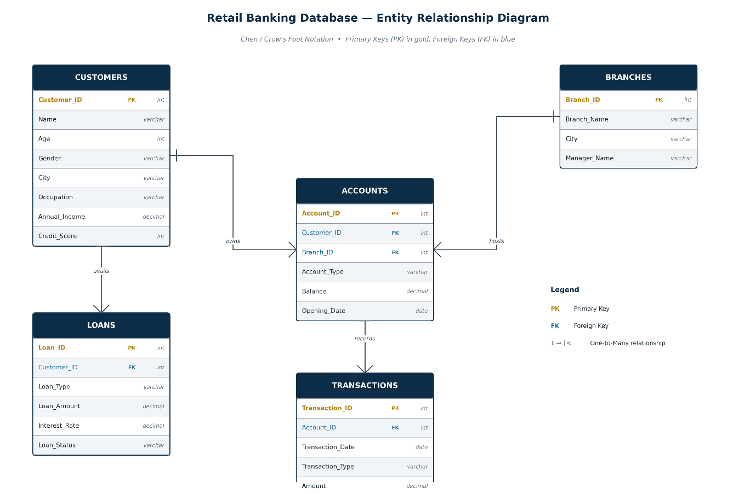

Relationship Explanation and Data Flow
The power of this database design lies in its referential integrity and the logical flow of data between entities.

a. Customer-Account Relationship (One-to-Many)
A single Customer can own multiple Accounts (e.g., a Savings account for personal use and a Current account for business). This relationship is maintained via the Customer_ID foreign key in the Accounts table.

b. Account-Transaction Relationship (One-to-Many)
Each Account acts as a parent to thousands of Transactions. By linking transactions to an Account_ID rather than a Customer_ID directly, we maintain a granular audit trail of money movement.

c. Branch-Account Relationship (One-to-Many)
Branches serve as the physical host for Accounts. Each account is attributed to a specific Branch_ID. To resolve complexities where a customer might have accounts at multiple branches, analytical reports requiring customer-to-branch attribution adopted a consistent "Primary Branch" assignment based on the earliest associated account. This ensured each customer contributed to only one branch during branch-level customer analysis while preserving account-level relationships elsewhere.

d. Customer-Loan Relationship (One-to-Many)
Loans are granted at the individual Customer level. This allows for the calculation of the Loan-to-Income (LTI) ratio, a critical risk metric derived by joining the Loans table with the Customers table to compare debt levels against annual earnings.

Normalization Process and Structural Integrity
To achieve a high-end architecture, the database underwent a rigorous normalization process to eliminate data redundancy and prevent update anomalies.
- First Normal Form (1NF): Ensured that every column contains atomic values and that every record is uniquely identifiable via a Primary Key.
- Second Normal Form (2NF): Eliminated partial dependencies by ensuring all non-key attributes (like Account Balance) are fully dependent on the primary key (Account_ID).
- Third Normal Form (3NF): Removed transitive dependencies. For example, branch manager names are stored in the Branches table rather than the Accounts table, ensuring that a change in management only needs to be updated in one location.

Handling Join Multiplication
A significant challenge addressed during the design phase was "Customer 360 Join Multiplication". When joining multiple "one-to-many" tables (Accounts, Transactions, Loans) directly to a Customer record, row duplication can lead to inflated totals. Our solution involved pre-aggregating each entity independently within the SQL Analytical View Layer before the final join, ensuring that total balances and transaction counts remain mathematically accurate.
This design principle became the foundation of the Customer 360 analytical view and ensured every customer appeared exactly once with validated aggregate metrics.

The Analytical View Architecture (Reporting Layer)
The final stage of the database design was the creation of Business-Purpose Views. These views serve as the interface for Power BI and demonstrate high "data modeling maturity".
- vw_customer_360: Consolidates all customer-related metrics (total accounts, balances, and loans) into a single, flat reporting row per customer.
- vw_customer_activity: Classifies customers into activity segments based on account ownership, transaction frequency, and transaction value.
- vw_customer_primary_branch: Assigns each customer to a single primary branch based on the earliest account opened, ensuring unique branch ownership for reporting.
- vw_customer_value_segment: Segments customers into Premium, Regular, and Low Engagement categories using a business-defined customer value scoring model.
- vw_high_value_customers: Identifies high-value customers using customer value scores and financial performance metrics for relationship management analysis.
- vw_approved_loan_portfolio: Focuses exclusively on active bank exposure, filtering out rejected applications to show the actual outstanding loan book.
- vw_loan_application_risk: Analyzes the full application funnel (Approved vs. Rejected vs. Pending) to provide a view of credit decision-making health.
- vw_loan_product_analysis: Summarizes approved loan portfolio performance by loan product, including exposure, loan count, average loan size, and portfolio contribution.
- vw_loan_product_risk_analysis: Analyzes average loan-to-income ratio and credit risk characteristics across different loan products.
- vw_loan_risk_analysis: Classifies approved loans into Low, Medium, High, and Critical risk categories using Loan-to-Income Ratio thresholds derived from project analysis.
- vw_credit_risk_summary: Summarizes loan portfolio exposure across risk categories for executive credit risk monitoring.
- vw_branch_performance: Aggregates deposits, transactions, and customer counts by branch to enable performance ranking and resource allocation.
- vw_branch_loan_reconciliation: Reconciles assigned and unassigned approved loans to validate branch-level loan allocation and data quality.
- vw_transaction_activity: Summarizes monthly operational trends, allowing the bank to monitor peak liquidity periods and digital banking adoption.
- vw_transaction_kpis: Provides overall transaction KPIs such as total transactions, total transaction value, average transaction amount, and related performance metrics.
- vw_account_product_analysis: Provides account product-wise metrics including customer count, account count, deposits, and average balances for product performance analysis.
- vw_executive_kpis: Provides executive-level banking KPIs such as customers, deposits, loans, transactions, and portfolio exposure for the overview dashboard.
Each reporting view was validated against the underlying tables before being integrated into Power BI, ensuring consistency between analytical outputs and source data.

Conclusion
The database design for this banking project translates to simple data storage. By choosing a relational RDBMS framework, enforcing strict normalization, and implementing a Analytical View Layer that encapsulates reusable business logic and pre-aggregated metrics.
I have created a system that is both operationally efficient and analytically powerful. This architecture successfully effectively manages complex banking relationships while preserving referential integrity and analytical consistency.

Chapter 3: SQL Development

Introduction
During SQL Development, my primary objective was not merely to write queries that return rows, but to architect a performance oriented, scalable, and business-accurate analytical layer. In modern banking, the database is more than a storage bin; it is the engine of decision-making.
The development process for this project followed a rigorous lifecycle: moving from raw data exploration and cleaning to the implementation of complex business logic using advanced SQL features, and finally, the construction of a Reporting View Layer that serves as the standardized analytical interface between the operational database and the Power BI semantic model.
This chapter details the reasoning behind every major architectural decision, explaining how the database transitioned from a transactional schema to a sophisticated analytical framework.

Data Exploration
Before writing a single line of analytical code, I thoroughly analyzed the data's structure and quality.

Validating Relationships and Cardinality
A common pitfall in banking projects is assuming that relationships are simple. We used exploratory queries like SELECT COUNT(DISTINCT Branch_ID) FROM Accounts to verify the distribution of 7,500 accounts across the branch network.
During this process, we identified a critical operational reality: while the bank had 10 branch IDs, two branches (108 and 109) showed zero activity. This was identified using the following query: 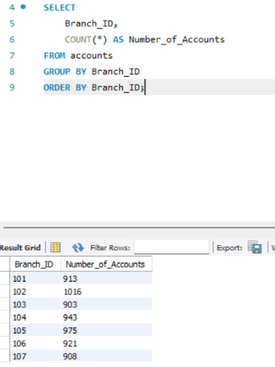
Branches 108 and 109 have no accounts, highlighting a data quality issue.
Instead of deleting these records, we made the architectural decision to retain them but document them as "Inactive Branch Records" to maintain referential integrity with the physical branch table.
These findings were validated against the source tables before being documented as a data quality consideration.

Identifying Anomalies
We investigated edge cases, such as "How can a person be a customer but have 0 accounts?". By running LEFT JOIN operations between the Customers and Accounts tables, we identified approximately 1,092 inactive customers. This led to our first business logic definition: an "Active Customer" is defined as a customer with at least one linked account. Understanding these nuances early prevented mathematical errors in our final KPIs.
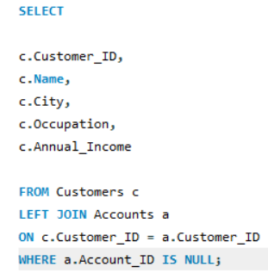
This query returned 1,092 rows thus showing the number of Inactive Customers (customers without an account)

Data Cleaning
Data cleaning in a banking context is about ensuring mathematical consistency and structural integrity.
- Referential Integrity Checks: We performed rigorous checks to ensure that no Transaction existed without a corresponding Account_ID and no Loan existed without a valid Customer_ID.
- Validation of Mandatory Fields: We implemented checks to ensure that mandatory fields like Loan_Status and Loan_Amount were fully populated, ensuring that our "Total Loan Exposure" metrics were not skewed by missing data.

Implementing Business Logic through SQL
The bridge between raw data and business insight is Business Logic. This is where SQL was used to translate vague banking concepts into actionable insights.

Defining the "Primary Branch"
One of the most complex decisions involved attributing customer value to a branch. Customers often have multiple accounts at different branches. To prevent a customer's total balance from being double-counted across regions, we implemented Primary Branch Logic.
Reasoning: We attributed a customer to the branch where they opened their first account (the Account_ID with the earliest opening date). This ensured that when we ranked branches by deposit performance, each customer’s value was attributed to exactly one location, providing a clean One-to-One relationship for regional performance analysis.
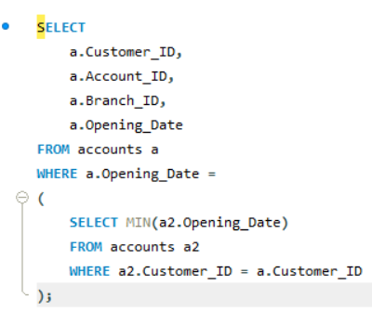
The query used for customer primary branch mapping.
This business rule was applied only for branch-level customer attribution and did not modify the underlying operational relationships between customers, accounts, and branches.

Risk Tiering Logic
Risk management is the heartbeat of banking. We didn't just report loan amounts; we created a Risk Tiering Framework based on the Loan-to-Income (LTI) ratio.
- Low Risk: LTI < 2
- Medium Risk: 2 to < 5
- High Risk: 5 to < 10
- Critical Risk: ≥ 10
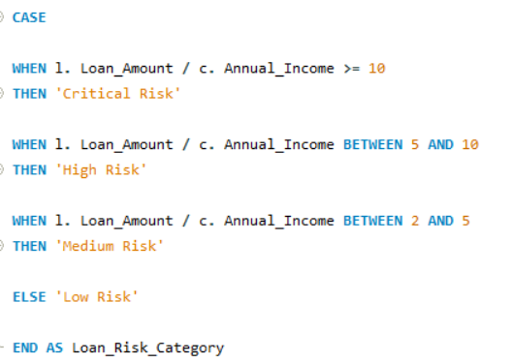
Embedding this logic into the SQL views, allowing analysts to immediately identify High and Critical Risk borrowers based on the standardized LTI thresholds.

Analytical SQL Techniques
To handle the complexity of banking data, we utilized a high-level SQL toolkit.

CASE Expressions: The Engine of Segmentation
We used CASE expressions to transform continuous variables into meaningful business categories. For example, Annual_Income was segmented into 'Low', 'Middle', and 'High' categories.
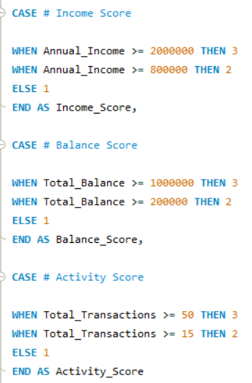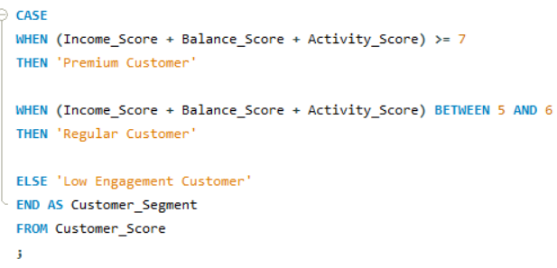
Reasoning: This segmentation allows the bank to design targeted products—wealth management for high-income segments and basic savings products for lower-income segments. Without CASE expressions, the data remains a list of numbers; with them, it becomes a strategic roadmap.

Window Functions: Ranking and Trends
Banking is a game of comparison. We heavily utilized Window Functions to perform advanced calculations without the need for cumbersome self-joins.
- RANK() OVER(): Used to rank branches based on deposit contribution and total customers. This provides managers with a merit-based view of their physical footprint. 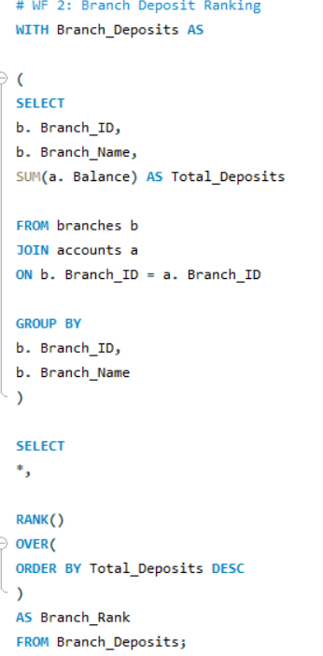
- SUM() OVER(): We implemented a Running Transaction Total to track liquidity over time. By ordering by Transaction_Date and Transaction_ID, we could see exactly how the bank's cash position evolved after every single transaction.
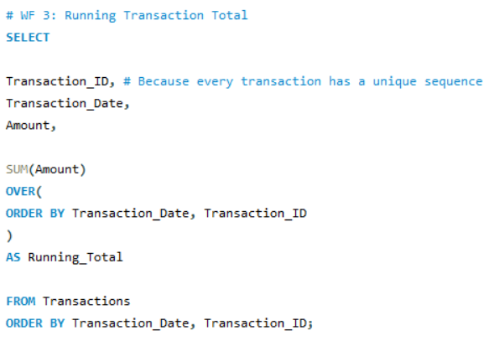

Common Table Expressions (CTEs): Managing Complexity
CTE's were our preferred method for building multi-step aggregations. The reasoning for using CTEs over subqueries was twofold: readability and modularity.
For the Customer Value Score, we used a CTE to first calculate individual scores for income, balance, and activity, and then a final SELECT to sum those scores into a single Customer_Value_Score.
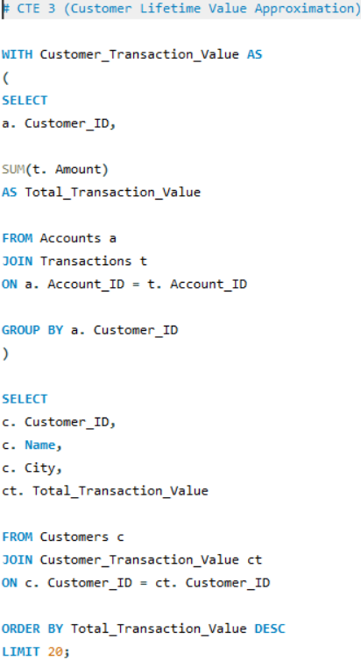
Each CTE was independently validated before being incorporated into the final analytical query.

Solving the "Join Multiplication" Problem
Perhaps the most critical senior-level decision in this project was the resolution of Join Multiplication.

The Problem
When joining a Customer table to an Accounts table (One-to-Many), and then joining that to a Transactions table (One-to-Many), row duplication occurs. If a customer has 2 accounts and each account has 10 transactions, joining them directly creates 20 rows of customer data. If you then SUM() the customer's balance, you get 20 times the actual amount.

The Solution: Pre-Aggregation
We made the architectural decision to pre-aggregate each entity independently within our analytical views before performing the final joins.
- We created a CTE for Account_Summary (aggregated by Customer).
- We created a CTE for Transaction_Summary (aggregated by Customer).
- We joined these pre-summarized results back to the Customer table. The resulting Customer 360 view was validated against source aggregates to confirm that balances, loan amounts, and transaction counts exactly matched the transactional database.
A hallmark of this project's maturity is the use of a dedicated Reporting View Layer. We decided early on that Power BI should never connect directly to base tables. 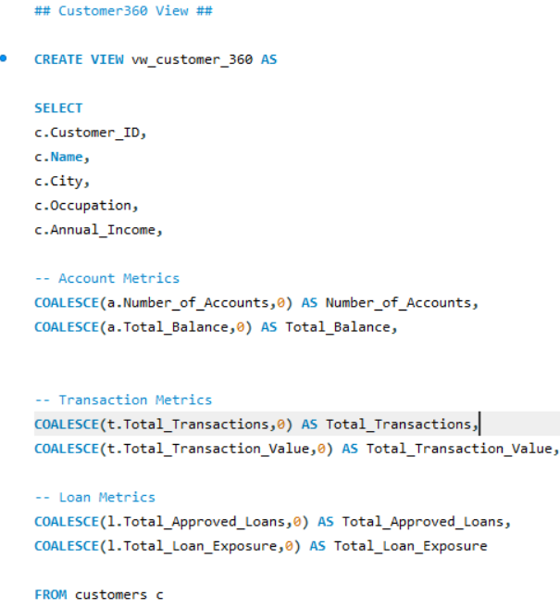
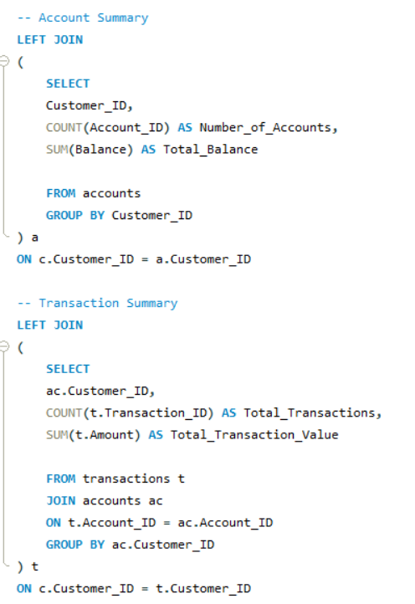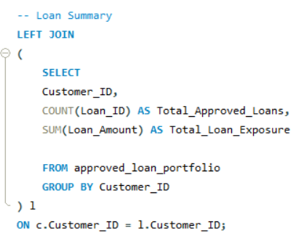

Separating Origination from Portfolio Exposure
A major design decision involved the loan data. Initially, we considered a single loan view, but we decided to split it into a specialized view showing only approved loans:
vw_approved_loan_portfolio: Focuses exclusively on the bank’s actual exposure by filtering for only "Approved" loans.
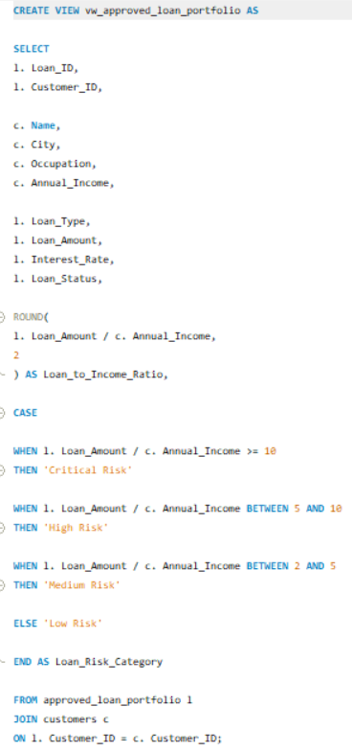
Reasoning: Mixing rejected applications with actual lending exposure creates a "muddled" analytical story. Separating them demonstrates an advanced understanding of banking practices, where "Origination Funnel" and "Book Exposure" are different business functions.

The Customer 360 View (vw_customer_360)
This view is the "Crown Jewel" of the project. It shows demographics, total account balances, total transactions, and total loan exposure into a single wide table.

Reasoning: This simplifies the Power BI Model significantly. Instead of creating complex relationships between multiple fact tables, Power BI can treat vw_customer_360 as a comprehensive source for customer-centric visuals, ensuring high performance and easier DAX calculations.

Stored Procedures:
While our Analytical View Layer provided the backbone for broad, multi-dimensional reporting in Power BI, a good database architecture must also provide tools for targeted, operational decision-making.
To address this, we implemented a suite of Stored Procedures. The strategic reasoning behind using procedures over standard queries was to encapsulate complex business logic into reusable, parameterized modules that could be called by application developers or frontline staff without them needing to understand the underlying schema.


The Operational Search Engine: sp_Get_Customer_Profile
One of the most frequent requests from a retail banking branch is a comprehensive look at a single customer’s standing. Instead of forcing a relationship manager to join four separate tables, we developed sp_Get_Customer_Profile.
- Logic and Reasoning: This procedure accepts a single IN parameter, cust_id_input. Internally, it utilizes a series of LEFT JOINs across the Customers, Accounts, and Loans tables.
- The Problem it Solved: During development, we observed that customers with zero accounts were still appearing in the database. We used this procedure to ensure that even inactive customers could be searched, returning 0 or NULL for financial metrics rather than simply failing to return a record. This provides the branch manager with a holistic view: "Yes, the customer exists, but they have no active accounts".
- Technical Implementation: We used GROUP BY on the customer’s unique attributes to ensure that even if a customer had four accounts, the procedure would return a single summarized row containing Total_Accounts, Total_Balance, Total_Loans, Total_Loan_Amount and Customer_Status.

Real-time Engagement Monitoring: sp_Get_Customer_Transaction_Summary
To support the digital banking team's effort to monitor customer activity, we created a procedure focused specifically on money movement: sp_Get_Customer_Transaction_Summary.
- Logic and Reasoning: This procedure calculates the Total_Transactions, Total_Transaction_Value and Average_Transaction_Value for a specific account holder.
- The "Zero-Activity" Validation: During testing, we identified that for certain IDs (like 10012), the procedure would return a blank result if no transactions existed. This led to a refinement of our logic: we ensured the procedure utilized COALESCE or similar logic in our reporting views to handle cases where a customer is active but hasn't yet performed a transaction, ensuring the output is always clean for the end-user.

Strategic Advantage of Procedures in Banking
Choosing to implement these procedures served three senior-level architectural goals:
- Security through Abstraction: By granting users permission to execute procedures rather than granting SELECT access to the base tables, we added a layer of security over sensitive financial data.
- Performance: Procedures are pre-compiled by the MySQL engine. For frequent lookups—such as checking a customer’s loan risk before a meeting—this is significantly more efficient than running a raw join every time.
This layer of Stored Procedures completes the SQL development lifecycle, moving the project from static data exploration to a dynamic, operational banking toolset.

SQL Optimization Decisions
To ensure the system remained responsive as data grew, we implemented several optimization strategies.
- Indexing: SQL queries were designed to minimize unnecessary joins and redundant calculations. Query execution plans were reviewed during development to ensure efficient execution where appropriate.
- Business Logic Centralization: By moving complex logic (like LTI ratios and rankings) into Views, we shifted the computational load from the client-side (Power BI) to the server-side (MySQL), which is significantly more efficient at handling large-scale joins.
- Cardinality Reduction: For operational monitoring, we created vw_transaction_activity, which aggregates 50,000 transactions into monthly summaries by type. This reduction in rows significantly improves the responsiveness of trend charts in the dashboard.

Conclusion: An Analytical Framework
The SQL development process for this banking project was governed by integrity, accuracy, and performance. By utilizing advanced techniques like Window Functions and CTEs, and by solving complex architectural issues like Join Multiplication, we built more than just a database—we built an analytical framework.
Combined with the hybrid Power BI data model, this SQL architecture provided a scalable foundation while maintaining the integrity of the normalized operational database.
The resulting Reporting View Layer ensures that every KPI on the bank’s dashboards is backed by validated, optimized, and business-relevant SQL logic. This project stands as a testament to the power of SQL to transform fragmented transactional data into a unified, strategic asset for financial leadership.

Chapter 4: Power BI Development

Executive Summary
This report details the architectural and design implementation of a multi-tiered Power BI solution for a retail banking institution managing a dataset of 5,000 customers, 7,500 accounts, 50,000 transactions, and 2,000 loan records.
The objective was to move beyond basic visualization and create a "reporting-ready" environment where complex banking logic is handled by a back-end SQL architecture, allowing Power BI to focus on high-performance data modeling, interactive visualisation and business storytelling.
The final solution consists of six specialized dashboards—Bank Performance Overview, Customer Analytics, Loan Risk, Branch Performance, Product Analysis, and Transaction Activity—each serving a distinct business audience.

The Data Model Architecture
The project utilizes a hybrid approach that bridges the gap between a normalized RDBMS and a reporting-optimized BI model. While the source system is a highly normalized relational database, the Power BI layer was designed to adhere to Star Schema principles to ensure calculation accuracy and report speed.

The Analytical View Layer (SQL-to-BI Interface)
A defining senior-level decision in this project was the implementation of a Dedicated Analytical View Layer. Rather than connecting Power BI directly to the raw, normalized base tables (which would require complex DAX to resolve many-to-many relationships), we created specialized SQL views for every dashboard.
Before integration into Power BI, each analytical view was validated against the respective underlying tables to ensure consistency between source data and dashboard metrics.
Key Reasons for Using Analytical SQL Views:
- Solving Join Multiplication: One of the primary challenges was "Customer 360 Join Multiplication". When joining Customers to Accounts and then to Transactions, metrics like "Total Balance" would inflate due to row duplication. By using SQL views to pre-aggregate entities independently before joining, we ensured that the "grain" of the table in Power BI remained strictly at one row per customer, guaranteeing 100% mathematical accuracy.
- Centralizing Business Logic: Complex banking definitions—such as identifying "Primary Branches" based on a customer's earliest account opening date or calculating Loan-to-Income (LTI) ratios—were embedded directly into the SQL views. This ensures that any change in business logic only needs to be updated in the database, automatically reflecting across all Power BI dashboards.
- Performance Optimization: By moving heavy calculations (like ranking 5,000 customers or 50,000 transactions) to the SQL server, we significantly reduced the computational load on the Power BI engine, resulting in faster visual rendering.

Star Schema Implementation
The Power BI semantic model follows a hybrid architecture that combines SQL reporting views with dimensional star-schema modeling. Business-oriented SQL views are imported directly where complex calculations have already been encapsulated, while dimensional tables and relationships are used where they improve filtering performance, DAX calculations, and report scalability.
- vw_transaction_activity provides the granular facts for monthly operational trends.
- vw_transaction_kpis serves as the executive summary table for overall transaction performance, including transaction count, transaction value, and average transaction metrics.
- vw_account_product_analysis serves as the analytical fact table for evaluating account product performance through customer counts, account volumes, deposits, and average balances.
- vw_approved_loan_portfolio acts as a table for approved lending exposure, providing customer-level loan details for credit risk and portfolio analysis.
- vw_branch_performance serves as the branch performance summary table by consolidating customer, deposit, transaction, and approved loan metrics for operational branch analysis.
- vw_credit_risk_summary provides aggregated portfolio-level credit risk metrics used for executive-level monitoring of loan risk distribution.
- vw_customer_activity acts as the analytical table for customer engagement by classifying customers into activity categories based on transaction behaviour.
- vw_customer_value_segment provides customer segmentation using a business-defined scoring model, enabling Premium, Regular, and Low Engagement customer analysis.
- vw_customer_360 serves as a comprehensive dimension for customer demographics.
- vw_high_value_customers identifies high-value customers based on customer value scores and financial performance, supporting customer profitability analysis.
- vw_loan_product_analysis serves as the analytical table for comparing approved loan products using portfolio size, exposure, average loan size, and portfolio contribution.
- vw_loan_product_risk_analysis provides product-level credit risk metrics by combining loan product performance with average Loan-to-Income Ratio analysis.
- vw_loan_risk_analysis acts as the primary analytical fact table for loan risk assessment by classifying approved loans into Low, Medium, High, and Critical risk categories.

Disabling Automatic Relationships
A deliberate architectural choice was to disable automatic relationships within Power BI. In a professional banking project, relying on the tool to "guess" relationships based on column names can lead to circular dependencies or incorrect joins, especially when multiple tables contain Customer_ID or Branch_ID. By disabling this feature, we maintained absolute control over the model.
Relationships were manually validated to ensure every analytical path reflected the underlying database relationships.
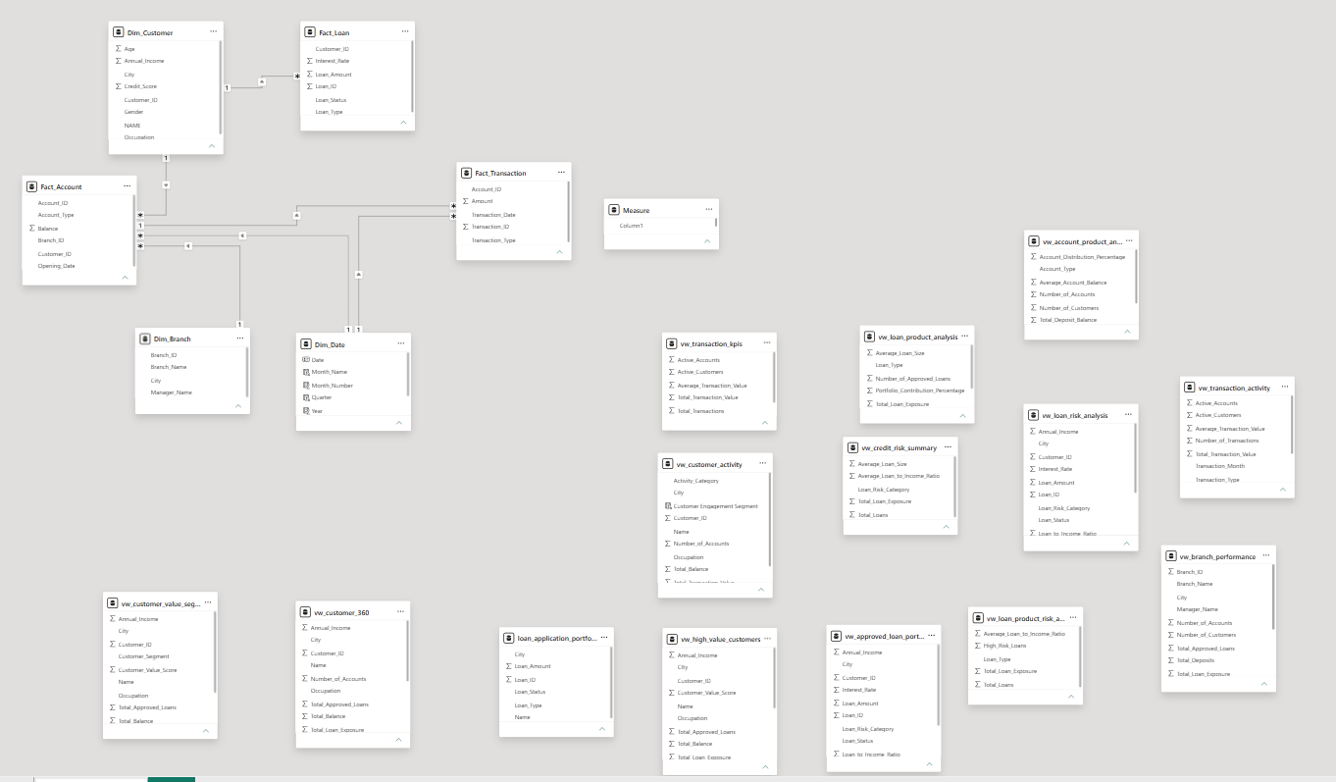

Dashboard Design Philosophy and Visual Selection
The solution was segmented into six dashboards to cater to specific organizational purposes.

Bank Performance Overview
- Audience: Senior Management.
- Design Philosophy: High-level KPIs that provide an "at-a-glance" health check of the entire bank.
- Visual Selection: Large KPI cards were used for "Total Deposits" (₹ 6.26bn) and "Loan Exposure" (₹ 2.82bn) to provide immediate context. A line chart was chosen for "Monthly Transaction Value Trend" to highlight long-term stability and peak activity months.
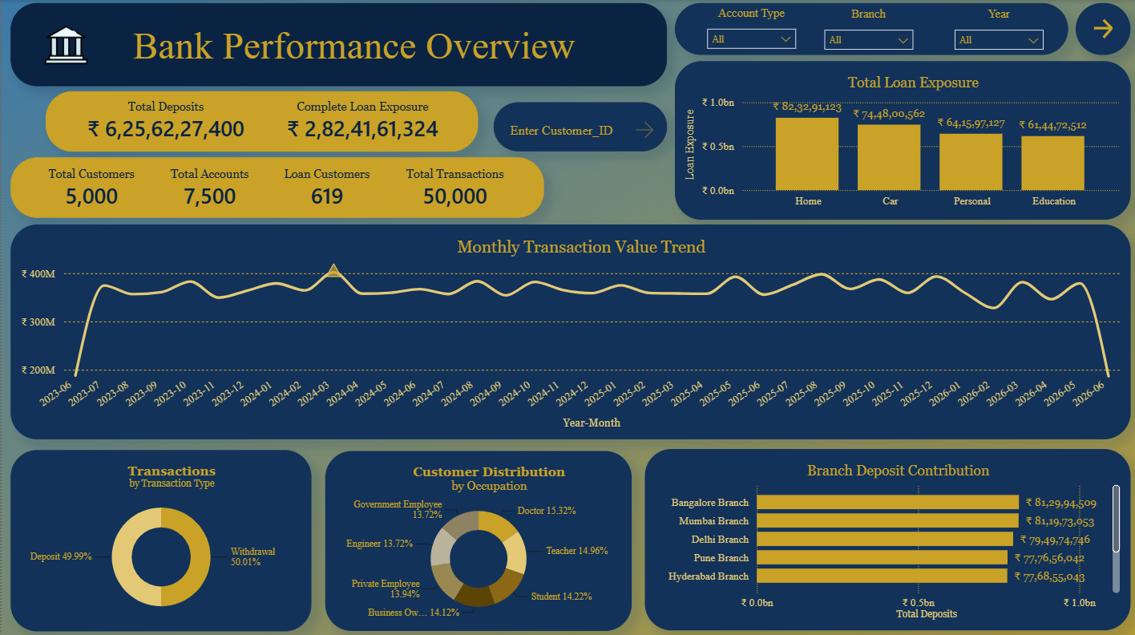

Customer Analytics Dashboard
- Audience: Relationship Managers.
- Design Philosophy: Deep-dive into demographic and value segments.
- Customer segmentation was complemented by Customer Value Scores to support relationship management and customer prioritization.
- Visual Selection: A donut chart for "Customer Segment Distribution" highlights that 39.22% (1961 customers) are "Premium Customers" and 61.65% are “Premium Customers by Total Transaction Value (₹ 8.17bn)”. Bar charts for "Customers by City" and "Customer Ranking" allow managers to identify high-value geographies and individuals for targeted wealth management.
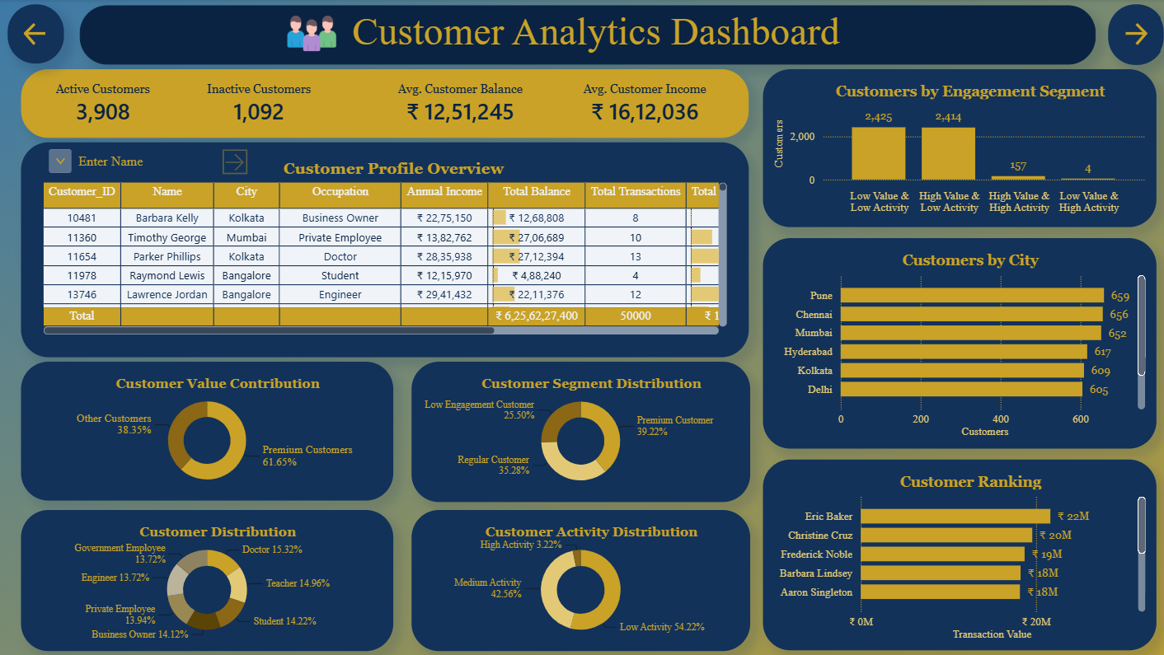

Loan Risk Dashboard
- Audience: Credit Analysts
- Design Philosophy: Analysis of Loan Risk and overall loan portfolio performance
- Visual Selection: A donut chart for "Risk Distribution" categorizes borrowers into Low, Medium, and High Risk based on their LTI ratios. A detailed table for "High Risk Loan Portfolio" enables credit analysts to act on individual loans where ratios are high (i.e., LTI > 5.0).
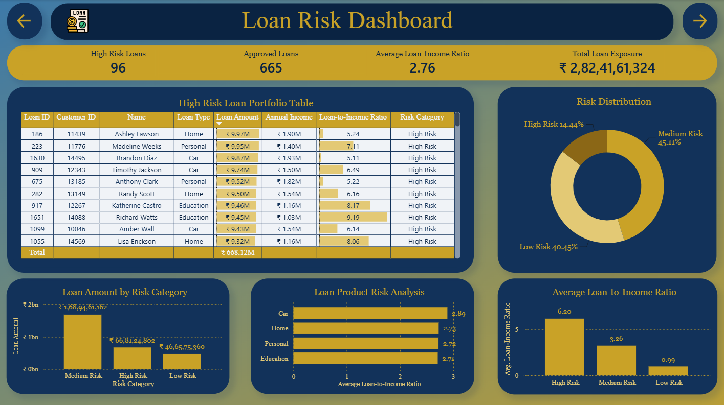

Branch Performance Dashboard
- Audience: Operations Managers.
- Design Philosophy: Comparative analysis of physical locations. Designed on the basis of Deposit Performance, Customer Base, Loan Contribution and Transaction Activity.
- Visual Selection: Horizontal bar charts were used to rank branches by "Deposit Contribution", “Loan Exposure” and "Customer Base". This ranking provides a merit-based view of the physical network, identifying top performers like the Bangalore and Mumbai branches.
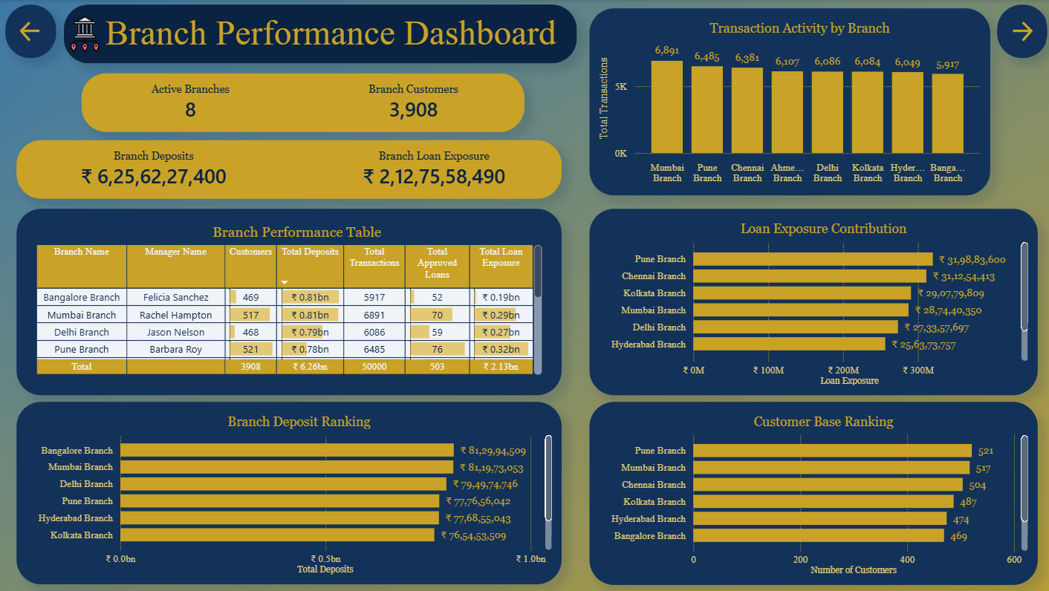

Product Analysis Dashboard
- Audience: Product Teams.
- Design Philosophy: Understanding adoption, contribution and profitability of different product offerings.
- Visual Selection: Donut charts compare "Savings" vs. "Current" accounts and different loan types (Home, Car, Personal, Education). Bar Charts show the contribution of product types.
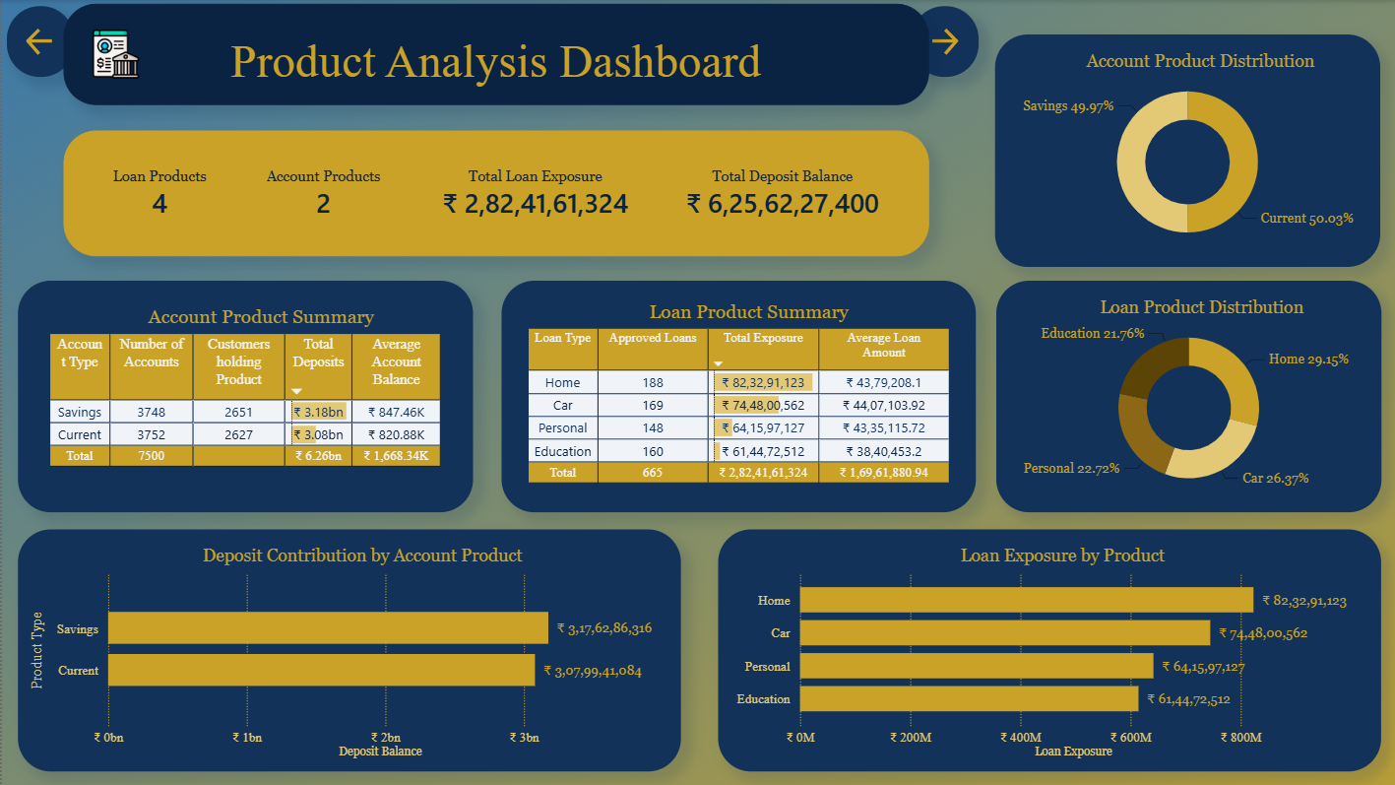

Transaction Activity Dashboard
- Audience: Digital Banking and Operations Teams.
- Design Philosophy: Operational monitoring of volume and trends.
- Visual Selection: A line charts for "Monthly Transaction Trends" and “Monthly Transaction Value” and a clustered column chart for "Transaction Type Distribution" (Deposit vs. Withdrawal).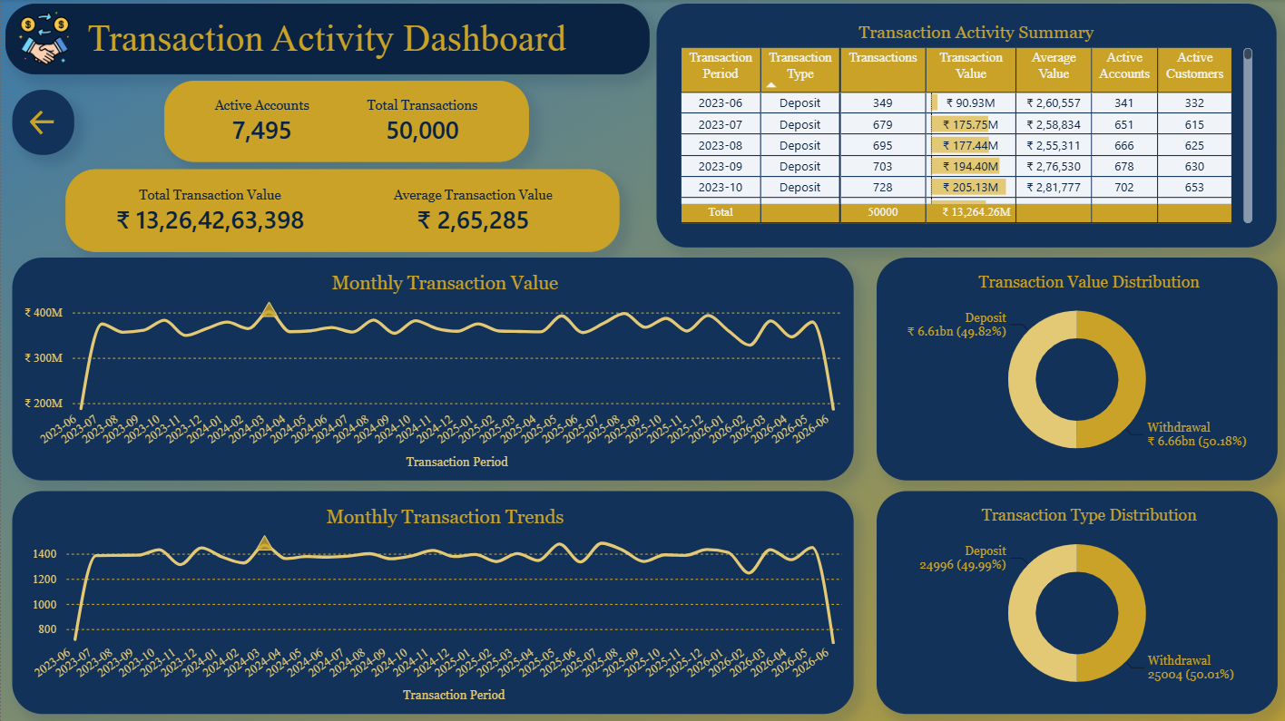

DAX Measures and Technical Refinement
While the heavy lifting was done in SQL, DAX was utilized for dynamic and non-additive calculations.
- Handling Non-Additive Counts: A critical data quality challenge involved counting "Active Accounts" in the transaction dashboard. Summing monthly distinct counts of accounts would result in over-counting (e.g., 47,790 accounts instead of ~7,500), as the same account may transact in multiple months. We addressed this by creating a dedicated KPI view or DAX measure (DISTINCTCOUNT) to ensure only unique accounts were counted across the specified time frame.
- Dynamic Averages: For "Average Transaction Value," DAX was used to divide total value by transaction count, ensuring the total row in a table displays a mathematically correct average rather than an "average of averages".
- Risk Categorization: Consistency was maintained by using the same LTI-based thresholds (<2 for Low, 2-5 for Medium, 5-10 for High, and ≥10 for Critical) across both the database and the BI layer.
Wherever possible, complex business rules were implemented in SQL rather than DAX. This reduced model complexity, improved maintainability, and ensured that identical business definitions were reused across every report.

Formatting and Professional Polish
To ensure the project was "portfolio-ready," strict formatting standards were applied.
- Visual Hierarchy and Navigation: A dark-blue and gold theme was applied for a "Premium Banking" feel. Navigation buttons and arrows were implemented to allow stakeholders to move seamlessly between the six dashboards.
- Tooltips: Every visual has an associated tooltip, allowing stakeholders to inspect the specifics of a particular visual.
- Standardization of Units: All financial metrics were standardized to Indian Rupee (₹) symbols with appropriate currency formatting.
- Sorting Logic: A common BI error—sorting months alphabetically—was resolved by creating a hidden YearMonthSort column, ensuring the "Monthly Transaction Value Trend" follows a logical chronological flow from 2023 to 2026.
- Conditional Formatting: In operational tables, data bars were used to highlight high-value transactions and outliers, allowing users to spot anomalies without reading every cell.
- Data Integrity Documentation: The model explicitly documents and handles inactive data, such as Branch 108 and 109, which exist in the system but have zero operational activity, preserving database integrity while maintaining business reality.

Conclusion
The Power BI implementation for this banking project demonstrates a sophisticated understanding of the BI lifecycle: Build → Validate → Polish → Present. By utilizing a view-driven architecture, resolving complex join multiplication in SQL, and applying strict Star Schema principles in Power BI, we have created a solution that is both accurate and insightful. This implementation provides a scalable blueprint for modern banking analytics, transforming fragmented data into a powerful tool for executive, operational, and risk-based decision-making.

Chapter 5: Dashboard Documentation

Introduction
The Analytics solution consists of six interactive Power BI dashboards, each developed to address a specific business function within the organization. Rather than creating a single report containing every metric, the dashboards were designed using a role-based approach, ensuring that executives, branch managers, relationship managers, credit analysts, and operations teams receive information relevant to their decision-making responsibilities.
Each dashboard is powered by validated SQL reporting views and a hybrid Power BI semantic model. Business rules—including customer aggregation, loan risk classification, branch attribution, and transaction summarization—are implemented within the SQL layer, while Power BI focuses on interactive analysis, visualization, and business storytelling.
This separation of responsibilities improves report performance, simplifies maintenance, and ensures consistent business definitions across the entire reporting environment.

Development Methodology
The dashboards were developed using a structured analytical workflow to ensure that every visualisation accurately represented the underlying data.
Business Requirement
↓
SQL Business Logic
↓
Analytical SQL Views
↓
Validation Against Source Tables
↓
Power BI Data Model
↓
DAX Measures
↓
Dashboard Design
↓
Testing & Validation
↓
Final Business Dashboard
Every dashboard underwent SQL-level validation before being imported into Power BI. This validation process ensured that dashboard metrics remained mathematically consistent.

Bank Performance Overview:


Business Objective:
To provide the administrative leadership with an overall assessment of the bank's financial health and operational performance.

Target Audience:
- Executive Management
- Senior Leadership

Visual Design Rationale:
The dashboard intentionally emphasizes high-level KPI cards and trend analysis to minimize cognitive load. Executives can evaluate organizational performance within seconds before navigating to more detailed analytical dashboards.

Business Questions Answered:
- What is the current financial position of the bank?
- How is overall business performance changing over time?
- Which business areas contribute most to overall performance?

Business Value:
Supports strategic planning, executive reporting, and performance monitoring.

Customer Analytics Dashboard:


Business Objective:
Provide a comprehensive Customer 360 analysis supporting customer segmentation, engagement monitoring, and relationship management.

Target Audience:
- Relationship Managers
- Customer Experience Teams

Visual Design Rationale:
Customer segmentation is supported using validated Customer 360 reporting views, ensuring every customer appears exactly once with pre-aggregated balances, transaction activity, and lending information. This eliminates duplicate customer records and provides consistent customer-level analytics.

Business Questions Answered:
- Who are the bank's highest-value customers?
- Which customer segments require targeted marketing?
- Where are customers geographically concentrated?

Business Value:
Supports customer retention, cross-selling opportunities, personalized banking services, and strategic customer acquisition.

Loan Risk Dashboard:


Business Objective
Evaluate lending performance while separating credit origination analysis from actual lending exposure.

Target Audience
- Credit Analysts
- Risk Management Teams

Architectural Design Decision
Maintaining separate reporting views prevents rejected applications from inflating exposure metrics and aligns with real-world banking practices.

Visual Design Rationale
Risk categories are consistently classified using standardized Loan-to-Income (LTI) thresholds:
- Low Risk (<2)
- Medium Risk (2–<5)
- High Risk (5–<10)
- Critical Risk (≥10)

Business Questions Answered
- Which borrowers represent elevated credit risk?
- How effective is the current lending strategy?
- Which loan products generate the greatest exposure?

Business Value
Supports credit monitoring, loan risk management, and lending policy evaluation.

Branch Performance Dashboard:


Business Objective
To evaluate and rank the operational and financial performance of the bank's physical branch network

Target Audience
- Operations Managers

Data Governance Consideration
Document the inactive Branch 108 and Branch 109 records and explain that they were retained to preserve database integrity and transparently represent operational data quality considerations.

Business Questions Answered
- Which physical locations are contributing most to the bank's deposit growth?
- Which branches require more staff or marketing resources?

Business Value
Drives operational excellence by identifying top-performing locations and providing a merit-based framework for resource and budget allocation

Product Analysis Dashboard:


Business Objective
To analyze the adoption, distribution, and financial contribution of the bank's account and loan products, enabling product performance evaluation and supporting future product development strategies.

Target Audience
- Product Managers
- Business Development Teams

Business Insight
The dashboard compares the performance of different account and loan products by analysing customer adoption, deposit balances, and loan exposure.
It also supports the evaluation of average customer holdings, allowing product teams to identify high-performing products, optimize pricing strategies, and explore opportunities for cross-selling and portfolio expansion.

Business Questions Answered
- Which banking products are most preferred by customers?
- Which loan products contribute the highest lending exposure?
- Which account products generate the largest deposit balances?
- Which products present opportunities for future growth and marketing initiatives?

Business Value
Supports product lifecycle management by identifying customer preferences, evaluating product performance, optimizing product offerings, and enabling data-driven decisions for pricing, promotions, and future product development.

Transaction Activity Dashboard:

Business Objective
To monitor banking transaction activity, customer engagement, and liquidity movement by analyzing transaction volumes, values, and operational trends over time.

Target Audience
- Operations Managers
- Digital Banking Teams
- Treasury and Liquidity Management Teams

Technical Implementation
The dashboard utilizes validated SQL reporting views together with Power BI measures to accurately summarize transaction activity. The Active Accounts KPI is calculated using DISTINCTCOUNT logic to prevent duplicate account counting across multiple reporting periods, ensuring mathematically accurate operational metrics. Monthly transaction summaries generated in SQL improve dashboard performance while maintaining consistency with the underlying transactional database.

Business Questions Answered
- How much transaction activity is occurring across the bank over time?
- Are deposits consistently exceeding withdrawals, indicating a healthy liquidity position?
- Which periods experience peak transaction volumes requiring additional operational capacity?
- How actively are customers utilizing their banking accounts?

Business Value
Supports operational monitoring, liquidity management, digital banking performance evaluation, and infrastructure planning by providing accurate insights into customer transaction behaviour while establishing reliable operational baselines for capacity planning and anomaly detection.

Conclusion
The dashboard suite for this Banking Analytics solution converts SQL analytics into role-specific business intelligence for organizational decision-makers. It uses a hybrid data model, standardized SQL reporting views, DAX measures, and consistent visualization principles.
This approach ensures each dashboard provides accurate, actionable, and relevant insights while maintaining analytical consistency. The six dashboards offer a comprehensive view of operational performance, customer behaviour, credit risk, product performance, branch efficiency, and transaction activity. This allows stakeholders at all levels to make informed, data-driven decisions.

Chapter 6: Challenges and Solutions

Executive Summary
This chapter serves as a technical analysis on the development of a comprehensive banking business intelligence (BI) platform.
I oversaw the transition from a normalized operational database to a sophisticated, view-driven Power BI ecosystem. Throughout this lifecycle, we encountered significant technical hurdles ranging from grain-level duplication to complex attribution logic. This report documents these challenges, our investigation processes, and the final architectural solutions that ensured a validated analytical architecture providing a standardized reporting interface between the normalized database and the Power BI semantic model.

Challenge 1: Customer 360 Join Multiplication (Metric Inflation)

Problem
During the initial development of the vw_customer_360 view, we observed that high-level KPIs, specifically Total Account Balance and Total Loan Amount, were significantly inflated when compared to raw base table sums.

Root Cause
The banking schema utilizes a one-to-many (1:M) relationship between Customers and Accounts, and another 1:M relationship between Customers and Loans. When joining these tables directly to create a "flat" customer profile, the SQL engine produced a row multiplication caused by joining multiple one-to-many relationships at the customer level. If a customer had two accounts and two loans, the join produced four rows for that single customer, effectively doubling the reported balances and loan exposures in the final SUM() operations.

Investigation
We performed a row-level audit of specific high-value customers. By running
SELECT * FROM Customers JOIN Accounts JOIN Loans WHERE Customer_ID = 10005, we confirmed that the customer’s $1.5M balance was appearing once for every loan record they possessed, leading to a massive overstatement of assets in the reporting layer.

Alternative Solutions Considered
- DAX-level Filtering: Using DISTINCTCOUNT or complex DAX filters in Power BI to ignore duplicates. This was rejected because it placed a heavy computational burden on the BI tool and made the data model difficult to maintain.
- SQL DISTINCT in Sums: Using SUM(DISTINCT Balance). This was rejected as it would incorrectly ignore legitimate duplicate balance values across different customers or accounts.

Final Solution
We implemented a Pre-Aggregation Strategy within the SQL Analytical View Layer. Instead of joining raw tables, we created independent Common Table Expressions (CTEs) for Account_Summary, Loan_Summary, and Transaction_Summary, each grouped by Customer_ID. These pre-summarized modules were then joined to the Customers base table. This ensured that the grain of the final view remained strictly at one row per customer.
The final Customer 360 view was validated against independent source aggregates to confirm that balances, loan amounts, and transaction counts exactly matched the underlying transactional tables.

Lessons Learned
In a complex relational environment, never join multiple "Many" tables to a single "One" table without first resolving the grain at the entity level.

Challenge 2: The Branch Loan Attribution Paradox

Problem
Branch-level reporting showed that the Total Loan Exposure for the bank was nearly triple the actual amount lent. While the Executive Dashboard showed ₹ 2.82bn, the sum of branch-level loans exceeded ₹ 6bn.

Root Cause
This was a logical attribution failure. Loans are recorded at the Customer level, but Accounts are recorded at the Branch level. Because many customers held multiple accounts across different branches (e.g., a Savings account in Kolkata and a Current account in Delhi), joining the Loans table to the Accounts table caused the same loan to be attributed to every branch where that customer had an account.

Investigation
An audit of Branch_ID 100 and Branch_ID 101 revealed that customers with inter-city accounts were being counted as "Loan Customers" in multiple jurisdictions simultaneously, creating "ghost exposure".

Alternative Solutions Considered
- Splitting Loans: Proportionally dividing a loan's value across all of a customer's branches. This was rejected as it does not reflect banking reality and complicates risk assessment.
- Assigning Loans to Branch 0: Placing all loans in a "Corporate" branch. This was rejected as it would lose valuable regional risk insights.

Final Solution
We established Primary Branch Logic. We defined a customer’s "Primary Branch" as the location where they opened their earliest account (determined by the lowest Account_ID and earliest Opening_Date). By attributing all of a customer’s products—including loans—to this single primary branch, we successfully removed all duplication while maintaining regional analytical integrity.
The Primary Branch rule was applied exclusively within the analytical layer and did not alter the underlying account-branch relationships stored in the operational database.

Lessons Learned
When fact tables exist at different levels of the hierarchy (Customer-level vs. Account-level), a deterministic attribution rule is required to maintain a clean Star Schema.

Challenge 3: Non-Additive Monthly Active Account Metrics

Problem
The Transaction Activity Dashboard reported an impossible 47,790 Active Accounts, despite the bank only having approximately 7,500 total accounts in the system.

Root Cause
The reporting view vw_transaction_activity aggregated data by Month and Transaction Type. In Power BI, we were using SUM(Active_Accounts). Because an account that transacts in every month from 2023 to 2026 is counted once per month, summing these monthly totals created massive over-counting. Distinct counts are non-additive across time dimensions.

Investigation
We compared the SQL result of SELECT COUNT(DISTINCT Account_ID) FROM Transactions (approx. 7,500) against the Power BI visual total (47,790), confirming that the BI tool was performing a simple sum of pre-calculated distinct counts.

Alternative Solutions Considered
- Using Base Tables in Power BI: Connecting directly to the Transactions table to use DAX DISTINCTCOUNT. This was rejected because it broke our design philosophy of using optimized SQL views as the primary reporting layer.
- Complex DAX over Views: Attempting to use DAX to "un-sum" the values. This was rejected as mathematically unsound.

Final Solution
We created a dedicated, single-row summary view: vw_transaction_kpis. This view calculated the absolute unique counts for the entire history of the bank at the database level. In Power BI, we used this view specifically for the KPI cards, while keeping vw_transaction_activity for the monthly trend charts where the monthly grain was appropriate.

Lessons Learned
Distinguish between Additive Metrics (like Transaction Value) and Non-Additive Metrics (like Distinct Customers) during the ETL phase to prevent end-user misinterpretation.

Challenge 4: Bifurcating the Loan Analytics Layer

Problem
The initial design for the "Loan Risk Dashboard" utilized the approved_loan_portfolio view as its sole source. However, this prevented the dashboard from displaying critical metrics like Approval/Rejection Rates and Pending Application Volume.

Root Cause
The approved_loan_portfolio view, by definition, filtered out all rejected and pending applications. While excellent for calculating actual bank exposure, it was insufficient for Credit Decision Analysis.

Investigation
We audited the business requirements for a "Risk Analyst" persona. We discovered that "Risk" in banking applies both to the Origination Funnel (whom are we letting in?) and the Active Book (how much have we lent?).

Alternative Solutions Considered
- One "Super View": Including all statuses in a single view. This was rejected because the analytical grain for a rejected application is different from an active loan, leading to "null-heavy" tables that confuse BI users.

Final Solution
We implemented an Approved Loan Portfolio Design:
- vw_approved_loan_portfolio: Included only approved loans to support exposure visuals like Total Loan Book and High Exposure Customers. This separation demonstrated high data modeling maturity by recognizing that different business populations require different sources.

Lessons Learned
Do not force a single data source to answer fundamentally different business questions. Split the data layer based on the business lifecycle.

Challenge 5: Referential Integrity vs. Operational Reality (Branches 108/109)

Problem
Initial data audits revealed that while the bank had 10 branches in its master table, Branches 108 and 109 showed zero customers, zero deposits, and zero transaction activity.

Root Cause
During data validation, Branch 108 and Branch 109 contained no associated operational records. This became a documented Data Quality Consideration

Investigation
We ran SELECT COUNT(*) FROM Accounts WHERE Branch_ID IN (108, 109) which returned 0. However, deleting these branches would have broken referential integrity if any future records were added, and would misrepresent the bank's physical footprint.

Alternative Solutions Considered
- Hard Deletion: Removing the branches from the database. Rejected, as it destroys historical/placeholder data.
- Merging: Attributing their (non-existent) data to other branches. Rejected as fraudulent reporting.

Final Solution
We chose to preserve the records for database integrity but documented them as "Inactive Branch Records". We ensured that all branch-ranking visuals in Power BI utilized INNER JOINs or filters to only display the 8 active branches, while the "Active Branches" KPI specifically excluded them to provide an accurate count of operational sites.

Lessons Learned
Data Architects must distinguish between Database Integrity (keeping all records) and Operational Relevance (only showing active ones).

Challenge 6: The "Missing" Customer_ID in Transactions

Problem
The requirement for "Customer 360" analysis required us to attribute transaction behaviour to individual customers. However, the Transactions base table did not contain a Customer_ID column; it only contained an Account_ID.

Root Cause
This is a standard normalized design where Transactions link to Accounts, and Accounts link to Customers. While efficient for storage, it creates a "hop" in the join path that complicates analytical queries.

Investigation
We mapped the ER Relationship Path: Transactions (FK: Account_ID) → Accounts (PK: Account_ID, FK: Customer_ID) → Customers (PK: Customer_ID).

Alternative Solutions Considered
- Schema Denormalization: Adding Customer_ID to the Transactions table. Rejected as it violates 3NF and risks data inconsistency.

Final Solution
We utilized Multi-Hop Joins within the View Layer. In the vw_customer_360 and vw_transaction_activity views, we explicitly navigated this relationship. This approach ensured that we maintained a clean normalized database while providing the BI layer with the customer-level insights it required.

Lessons Learned
Relational schema navigation is a core competency for BI development. The Analytical View Layer is the correct place to "flatten" these hops for reporting.

Challenge 7: Hybrid Approach (Views + Star Schema)

Problem
Using only normalized tables made Power BI unnecessarily complex, while relying solely on SQL Views reduced model flexibility.

Solution
The Power BI model adopted a hybrid architecture which involved:
- Analytical SQL views
- Star Schema using base tables

Conclusion: The Value of an Architected Approach
The success of this banking analytics project was not defined by the visuals themselves, but by the rigorous resolution of these technical challenges. By prioritizing:
- Independent pre-aggregation to solve join multiplication.
- Primary Branch Logic to solve attribution errors.
- Bifurcated Views to handle the credit lifecycle.
- Dedicated KPI Views to handle non-additive metrics.
- Validation of each output to ensure consistency between SQL outputs and Power BI visuals.
We created a system that is not only visually impressive but also mathematically bulletproof. This project uses a strategic and well-manages approach to use fragmented financial data for delivering a unified, strategic asset for the business.

Chapter 7: Business Insights

Introduction
This chapter presents the key business insights derived from the Banking Analytics solution.
By combining validated SQL reporting views with interactive Power BI dashboards, the project enables the identification of operational trends, customer behaviour, credit risk patterns, and product performance. Rather than presenting isolated metrics, the analysis focuses on translating analytical findings into actionable business insights and identifying opportunities for future enhancement.

Bank Performance Overview: Liquidity and Scale
- Findings & Meaning: The bank maintains a robust liquidity position with ₹6.26 billion in total deposits supporting a ₹2.82 billion loan portfolio. This indicates a conservative loan-to-deposit ratio, suggesting substantial room for capital deployment.
- Management Decisions: We may evaluate opportunities of an expansion of the credit portfolio to optimize interest income, the current deposit base exceeds the approved loan portfolio, indicating capacity for future lending subject to regulatory requirements and the bank's risk appetite.
- Operational & Strategic Recommendations: Operational teams should focus on streamlining the Home and Car loan pipelines, which currently dominate exposure. Strategically, the bank should leverage its 5,000-strong customer base to transition from a deposit-heavy institution to a more aggressive lending partner.
- Future Improvements: Implement liquidity stress-testing models within the dashboard to monitor real-time capital adequacy against market volatility.

Customer Analytics: The Engagement Gap
- Findings & Meaning: While 39.22% of our base are "Premium Customers," a significant majority (over 2,400 individuals) fall into the "Low Value & Low Activity" segment. Our value is concentrated in top-tier cities like Pune, Chennai, and Mumbai, but engagement is not uniform.
- Management Decisions: Redirect marketing budgets from general acquisition to targeted "retention and upsell" campaigns for the mid-tier segment.
- Operational & Strategic Recommendations: Relation managers should prioritize the top-ranked customers identified in our ranking visuals for bespoke wealth management. Strategically, we must develop tailored financial products that migrate low-activity users into the regular engagement tier.
- Future Improvements: Integrate Churn Prediction Modelling to identify at-risk customers before they move to competitors.

Loan Risk Dashboard: Portfolio Health
- Findings & Meaning: The portfolio is generally stable, but 14.44% is classified as "High Risk" based on Loan-to-Income (LTI) ratios. The number of rejected applications exceeds approved applications, suggesting an opportunity to further evaluate underwriting policies, applicant quality, or both.
- Management Decisions: Establish a "Watchlist" for the 96 high-risk loans that exceed the LTI threshold of 5.0.
- Operational & Strategic Recommendations: Operationally, refine the credit scoring engine to reduce the high volume of "Pending" applications, which stalls the revenue cycle. Strategically, re-examine the risk appetite for "Education" loans, which currently show the lowest average LTI ratios and could be a safer growth path.
- Future Improvements: Development of a real-time Default Early Warning System (EWS) using transactional behaviour as a proxy for creditworthiness.

Branch Performance: Regional Disparities
- Findings & Meaning: We currently operate 8 active hubs, with Bangalore and Mumbai leading in deposit contribution. However, Pune demonstrates the highest loan exposure, indicating it is our primary "borrowing" hub while Bangalore is our "saving" hub.
- Management Decisions: Allocate higher staffing and marketing resources to the Pune and Chennai branch to manage the large credit book, while focusing on wealth management hiring in Bangalore and Mumbai.
- Operational & Strategic Recommendations: Investigate the operational status and account assignment of Branch 108 and Branch 109 to determine whether they represent inactive operational units or data quality anomalies. Strategically, use the "Branch Ranking" data to create a merit-based incentive structure for branch managers.
- Future Improvements: Expansion of branch metrics to include "Profitability per Square Foot" and "Digital Adoption Rate per Branch."

Product Analysis: Adoption vs. Profitability
- Findings & Meaning: Account type adoption is perfectly balanced, with Savings and Current accounts each holding roughly 50% of the market. In lending, "Home Loans" represent the largest exposure (₹82.3M), indicating a portfolio heavily tied to long-term collateralized assets.
- Management Decisions: Product performance should continue to be monitored to identify opportunities for targeted marketing based on customer demographics and product adoption trends.
- Operational & Strategic Recommendations: Operationally, streamline the Car and Personal loan processing times to improve the churn of shorter-term assets. Strategically, diversify the product mix to reduce the risk in Home Loans which have the largest loan exposure.
- Future Improvements: Implementation of Next Best Product (NBP) algorithms to suggest the most likely second product a customer will adopt.

Transaction Activity: Operational Throughput
- Findings & Meaning: The bank processes a steady ₹350M in transactions monthly, with a nearly 50/50 split between deposits and withdrawals. The average transaction size of ₹2.65L indicates that customers conduct substantial financial transactions, warranting continued monitoring of transaction behaviour and liquidity patterns.
- Management Decisions: Ensure digital infrastructure is scaled to handle the peak transaction volumes observed in the "Monthly Trends" visual.
- Operational & Strategic Recommendations: Operationally, monitor the "Withdrawal" trends closely; any sustained period where withdrawals exceed deposits will require immediate liquidity adjustments. Strategically, use transaction frequency data to identify candidates for our upcoming Credit Card rollout.
- Future Improvements: Integration of Fraud Detection monitoring within the operational dashboard to flag anomalous transaction spikes in real-time.

Chapter 8: Lessons Learned
The completion of the Banking Management and Analytics System marks a significant milestone in transitioning from foundational data handling to a multi-layered business intelligence ecosystem. Managing this dataset required more than technical proficiency; it demanded a deep understanding of banking operations, data integrity, and stakeholder requirements.

1. Database Engineering
The foundational phase taught the importance of structural integrity and scalability.
- Normalized Design: Building a relational schema—spanning Customers, Accounts, Transactions, Loans, and Branches—required strict adherence to normalization principles to prevent update anomalies.
- Operational Readiness: I learned that a database is not just a storage bin; it must be validated and optimized. Implementing indexing on primary and foreign keys, and using relevant SQL statements to test performance on high-volume tables like Transactions (50,000 rows), proved critical for maintaining a responsive system.
- Identifying schema inconsistencies early reinforced the importance of maintaining standardized naming conventions throughout database development and reporting.

2. SQL Development
SQL served as the engine of reliability, and the project pushed our capabilities into advanced analytical querying.
- Deterministic Window Functions: I learned that functions like SUM() OVER(ORDER BY Transaction_Date) can produce inaccurate, "stepped" results for multiple transactions on the same day. The solution—implementing a tie-breaker column (ORDER BY Transaction_Date, Transaction_ID)—ensured a smooth and accurate running total.
- Encapsulation via Stored Procedures: Developing procedures like sp_Get_Customer_Profile taught the value of abstraction. This allows operational staff to retrieve complex summaries without needing to understand the underlying joins between accounts and loans.
- Logical Modularization with CTEs: Utilizing Common Table Expressions (CTEs) allowed me to build complex logic, such as the Customer Value Score (ranging from 3 to 9), in modular, testable steps. CTEs were also instrumental in solving Customer 360 aggregation challenges by independently summarizing transactional entities before combining them into a unified reporting view.

3. Data Modelling
Modelling revealed the complexity of relational "many" relationships in a financial context.
- Solving Join Multiplication: One of the most significant hurdles was "Join Multiplication". Directly joining multiple one-to-many tables (Accounts, Loans, Transactions) to a Customer record caused metrics like "Total Balance" to inflate. I learned to pre-aggregate entities independently in SQL before performing the final joins to maintain a strict "one row per customer" grain.
- Star Schema Principles: While the source was normalized, presenting data to Power BI in a Star Schema—using analytical views as clean Fact and Dimension tables—was essential for dashboard performance and ease of use.
- Primary Branch Logic: Establishing a standardized Primary Branch assignment demonstrated that analytical models often require additional business rules beyond the operational database structure.

4. Power BI Development
The primary lesson in development was the strategic advantage of a view-driven architecture.
- Hybrid Architecture: Combining SQL reporting views with a Star Schema semantic model provided an effective balance between centralized business logic and flexible interactive reporting.
- SQL as the Reporting Layer: I intentionally avoided complex DAX by using Analytical SQL Views to feed every dashboard. This centralized business logic in the database, making the Power BI model lighter and easier to maintain.
- Manual Relationship Control: By disabling automatic relationships, I maintained absolute control over the data model, preventing circular dependencies and ensuring that only validated links between tables were used.

5. Validation & Data Quality
Rigorous validation proved that a dashboard is only as good as the trust it inspires.
- Handling Non-Additive Metrics: I discovered that summing monthly distinct counts of accounts in vw_transaction_activity resulted in a count of 47,790—far exceeding the actual 7,500 accounts. This taught me that distinct counts are non-additive across time dimensions, leading me to create a dedicated vw_transaction_kpis view for accurate, single-row summaries.
- Documenting Inactive Data: Identifying Branches 108 and 109 (which contained zero customers or activity) highlighted the difference between technical integrity and operational reality. I chose to preserve them for database integrity while documenting them as inactive for stakeholders.

6. Documentation
Documentation was the connective tissue that transformed technical tasks into a professional product.
- Business-to-Technical Mapping: Maintaining a detailed log of core business questions and their corresponding SQL queries ensured that every technical effort was anchored in a business need.
- Analytical Roadmap: Documenting the Analytical View Layer provided a clear blueprint for developers, ensuring that metrics like "Active Customer" (at least one account) were standardized across the organization.

7. Dashboard Design
I learned that effective design is governed by persona-based storytelling.
- The 6-Dashboard Strategy: Designing for specific audiences—from Senior Management (Executive) to Credit Analysts (Loan Risk)—ensured that users were not overwhelmed by irrelevant data.
- Visual Hierarchy: For operational monitoring, such as in the Transaction Activity Summary, I learned that a Table is often superior to a Chart because it is easier to validate and export for daily tasks.
- Conditional Formatting as Insight: Instead of cluttered colours, I used Data Bars and single-color gradients to highlight high-value outliers without creating visual noise.
- Consistency: Maintaining consistent colours, typography, navigation, and KPI formatting significantly improved report usability and created a cohesive reporting experience.

8. Business Thinking
The project shifted our perspective from "what happened" to "what it means for the bank."
- Lifecycle Awareness: A major insight was recognizing the difference between Loan Origination (the funnel of applications, approvals, and rejections) and Portfolio Exposure (the active loan book). This led to splitting the data layer into two distinct views to better serve risk management.
- Interpreting Concentration Risk: I learned to look for "unnatural" ratios, such as Loan-to-Income (LTI) ratios exceeding 10.0, which indicate critical default risk rather than just a high loan value.

9. Personal Growth
Ultimately, this project a transition from a learner to a business analytics thinker.
- Problem-Solving Maturity: Encountering data quality issues and "unnatural" results taught me to investigate the root cause rather than just fixing the output.
- Professional Storytelling: I evolved from presenting raw SQL results to delivering executive-ready insights and recommendations. The project strengthened my ability to translate validated analytical findings into clear business insights supported by evidence rather than assumptions.
- Career Readiness: By documenting modelling maturity and end-to-end validation, strengthened practical skills in SQL, relational database design, data modeling, validation, and Business Intelligence development.
Conclusion
This project was a valuable learning experience in resilient business intelligence. It taught me that while data is often messy and relationships are complex, a disciplined approach to engineering, modelling, and design can turn fragmented data into the most powerful asset an organization possesses.

Final Conclusion
The completion of the Banking Management and Analytics System represents the successful delivery of a end-to-end Banking Analytics and Business Intelligence solution.
By transforming a raw, fragmented relational database into a suite of six specialized, high-performance dashboards, this project has established an analytical framework for a retail bank serving 5,000 customers across a diverse demographic. This concluding chapter summarizes the project's multifaceted achievements, the strategic value it offers to the institution, and the roadmap for future technological evolution.

Project Achievements
The primary achievement of this project is the successful orchestration of the entire data lifecycle—moving from business understanding and database design through SQL development, Power BI implementation, validation, dashboard development, and documentation. I have successfully engineered a robust relational database containing 7,500 accounts, 50,000 historical transactions, and over 2,000 loan records.
The project’s crown jewel is the delivery of six persona-based dashboards tailored to the specific needs of Executive Management, Relationship Managers, Credit Analysts, Operations Managers, Product Teams, and Digital Banking analysts. This suite provides a 360-degree view of banking health, spanning from high-level liquidity metrics (₹6.26bn in total deposits) to granular loan risk assessments based on individual debt-to-income ratios.

Technical Achievements
Beyond the visual layer, the project rests on a sophisticated technical foundation. Key technical accomplishments include:
- Normalized RDBMS Architecture: The implementation of a strictly normalized schema ensured data integrity and minimized redundancy across five core entities.
- The Analytical View Layer: We developed a dedicated layer of SQL Reporting Views (e.g., vw_customer_360, vw_loan_application_risk). This layer performs complex business logic—such as identifying "Primary Branches" based on earliest account opening dates—directly at the database level to ensure Power BI performance remains high.
- Advanced Problem Solving: The project successfully resolved industry-standard challenges, such as Join Multiplication (which previously caused metric inflation) and the Non-Additive Metric Paradox, where monthly active account counts were incorrectly summed.
- Performance Optimization: Through the use of Indexing and Window Functions, we engineered features like "Running Transaction Totals" that are deterministic and scalable, even as transaction volumes grow.
- Hybrid SQL + Power BI Architecture: The combination of SQL analytical views with a Power BI Star Schema provided a scalable reporting architecture that balanced centralized business logic with flexible interactive reporting.

Business Value: Transforming Data into Strategy
The implementation of this analytics framework delivers immediate, actionable value to the bank's leadership:
- Risk Mitigation: By categorizing the loan portfolio into Low, Medium, High, and Critical risk tiers based on Loan-to-Income (LTI) ratios, the bank can now proactively manage the 14.44% of the portfolio currently flagged as high risk.
- Operational Transparency: The Branch Performance Dashboard provides merit-based rankings, allowing management to identify top-performing hubs like Bangalore and Mumbai while documenting inactive locations such as Branch 108 and 109 for data quality governance.
- Customer Centricity: The Customer Analytics Dashboard allows relationship managers to target the 39.22% of the base identified as "Premium Customers" with wealth management products, while simultaneously identifying strategies for the "Low Engagement" segment.
- Liquidity Management: The Transaction Activity Dashboard provides a clear view of cash flow behaviour, monitoring the ₹13.26bn in total transaction value to ensure a healthy balance between deposits and withdrawals.
- Customer 360: The Customer360 reporting layer provides a unified customer view that supports relationship management, segmentation, and customer value analysis.

Portfolio Value
For an aspiring business analyst like myself, this project serves as a high-impact portfolio asset. It demonstrates far more than simple visualization; it showcases "Data Modelling Maturity".
- Business Thinking: The deliberate split between Loan Application Risk (funnel analysis) and Approved Loan Portfolio (exposure analysis) reflects real-world banking reporting practices that separate origination from active risk.
- Rigorous Validation: The project follows a strict "SQL = Power BI" validation methodology, ensuring that every visual is cross-checked against database counts, a level of accuracy often missing in purely academic projects.
- Problem-Solving Narratives: The documentation of challenges—such as resolving branch attribution errors—provides "STAR stories" (Situation, Task, Action, Result) that are essential for demonstrating technical competence during professional interviews.

Future Enhancements
While the current implementation provides a robust baseline, the following enhancements represent the next stage of evolution:
1. Predictive Analytics & AI Integration
The natural progression of this system is from descriptive to predictive analytics. By integrating Machine Learning models (e.g., Python/R), the bank can implement:
- Churn Prediction: Identifying customers with declining transaction frequency who are likely to move to competitors.
- Probability of Default (PD) Models: Moving beyond simple LTI ratios to multi-factor risk scores that predict the likelihood of a loan default.
- AI-Powered NLP Queries: Utilizing Power BI’s "Q&A" feature to allow executives to ask natural language questions (e.g., "Which branch had the highest car loan approvals in 2025?") and receive instant visual answers.
2. Real-time Banking Analytics
The current system operates on a batch-processing model. Future iterations should move toward streaming data integration. By connecting to live transaction streams, the bank can implement:
- Instant Fraud Detection: Triggering alerts when transaction spikes occur outside of a customer’s normal behavioural baseline.
- Real-time Liquidity Monitoring: Providing an up-to-the-minute view of the bank's cash position rather than waiting for end-of-day reports.
3. Cloud Migration & Scalability
To support global scale and high availability, migrating the local MySQL environment to a cloud-based architecture (e.g., Azure SQL Database or AWS RDS) is recommended.
- Auto-scaling: Ensuring the database can handle millions of transactions without performance degradation.
- Centralized Governance: Utilizing cloud-native tools like Azure Synapse for even more advanced data warehousing and integration with external market data.
4. Customer Lifetime Value Prediction Model: Future iterations may incorporate Customer Lifetime Value (CLV) prediction and recommendation models to support personalized banking services and cross-selling opportunities.

Closing Remarks
This project stands as a testament to the power of a well-architected business intelligence solution. I have navigated the complexities of financial data—balancing the need for strict database integrity with the demand for intuitive, strategic insights. By prioritizing accuracy, validation, and professional design, I have created a tool that does more than report on the past; it empowers the bank's leadership to navigate the future with confidence.
Beyond the technical implementation, this project demonstrates the importance of combining database engineering, analytical thinking, business understanding, and effective data visualization within a single solution. It illustrates how reliable data architecture and well-defined business rules can transform raw operational data into meaningful insights that support informed decision-making. The experience gained throughout this project establishes a strong foundation for future work in data analytics, business intelligence, and financial data management.
The Banking Management and Analytics System is a scalable blueprint for banking analytics implementations to transform their data into a decisive competitive advantage.

